CHILDREN’S PARTY REQUEST FORM

We are delighted that you would like to hold your child’s birthday party at the Ian Robinson Sports Centre. Please see below the packages we offer!
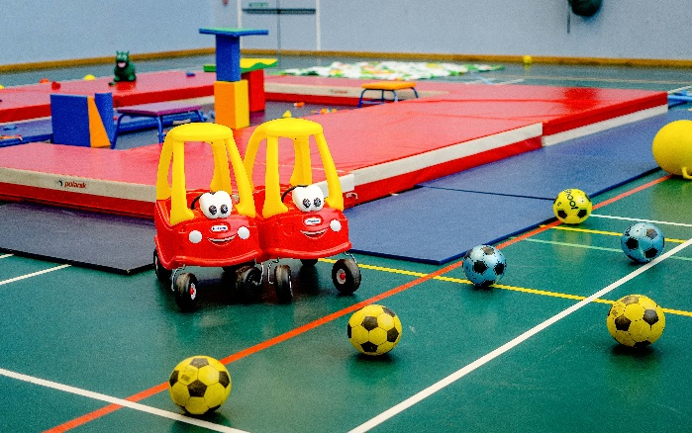
Soft Play Party - £100.00
- Function Room Sports Hall hire
- Soft play equipment included
- Suitable for up to 20 children aged 0-4 years.
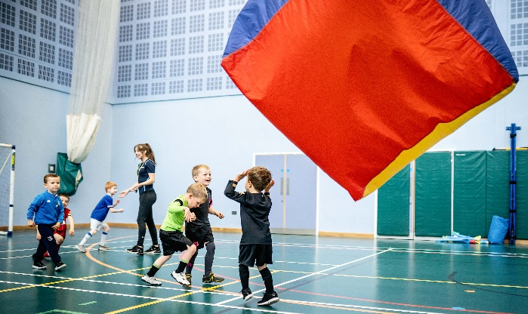
Hire and Play Party Package - £100.00
- Function room and sports hall hire included
- Sports equipment of your choice
- Suitable for children aged 4-11 years.

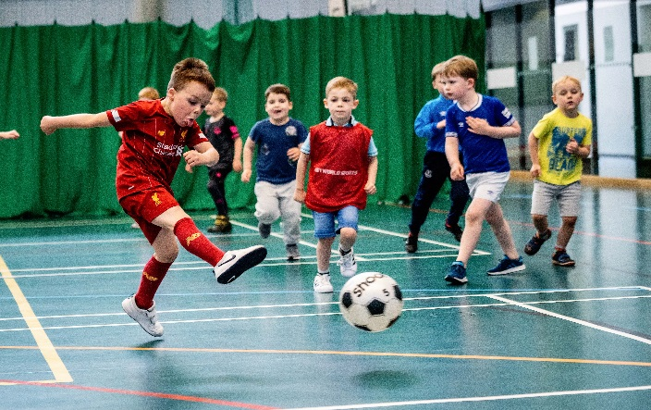
Sports Party Package - £160.00
- Sports supervisors to deliver the activities
- Party invitations and sports bags included
- Up to 20 children aged 4-6 yrs
- Up to 30 children aged 7-11 yrs
- Function room and sports hall hire included
- 90 minutes of your chosen sports

Access to the facilities will be available 30 mins prior to booking start date depending on availability.
To book, please complete the booking form overleaf.

Parent/Guardian Name:
Contact Number:
Email Address (BLOCK CAPS):
Date Requested: Name of party boy/girl:
Party Type | Price
Sports Party - up to 20 children aged 4-6 years  (Please select up to 3 sports from the section below)  Saturday 12.00pm – 2.00pm 2.00pm – 4.00pm | £160.00
Sports Party – up to 30 children aged 7-11 years  (Please select up to 3 sports from the section below)  Saturday 12.00pm – 2.00pm 2.00pm – 4.00pm | £160.00
Soft Play Party – up to 30 children aged 0-4 years  Saturday 12.00pm – 2.00pm 2.00pm – 4.00pm  Sunday 11.00am – 1.00pm 1.00pm – 3.00pm | £100.00
Hire and Play Party – up to 30 children aged 4-11 years  (Please select equipment from the section below)  Saturday 12.00pm – 2.00pm 2.00pm – 4.00pm  Sunday 1.00pm – 3.00pm | £100.00
Basketball Parachute Games
Dodgeball IRSC Fun and Games (Sports Party only)
Football Other: Please explain where necessary!
Refundable £20 deposit required for all bookings. See T&Cs for further info.
GDPR | We need your consent to store and process your information. Please see the Merchant Taylors' Schools Privacy Notice for more information
Marketing | Do we have your consent to send marketing emails? Yes: No:

I understand that by making this request I am agreeing to adhere to the full terms and conditions of the children’s birthday party service available from the Ian Robinson Sports Centre website and reception area.
Signed: Date:
Office Use Only:
Deposit Booked on EZ: Confirmed Via Email Paid in full Invitations Issued
Staff Name and Date

